Homework 9 Yubing Li 00808366

**1. Problem 7.4:**

(a) For A=speed, B=Geometry, C=Angle, the table is:

|  |  |  |  |  |  |  |  |  |  |
| --- | --- | --- | --- | --- | --- | --- | --- | --- | --- |
| Treatment Combination | Factorial Effect | | | | | | | | |
| I | A | B | AB | C | AC | BC | ABC | Block |
| (1) | + | - | - | + | - | + | + | - | 1 |
| a | + | + | - | - | - | - | + | + | 2 |
| b | + | - | + | - | - | + | - | + | 2 |
| ab | + | + | + | + | - | - | - | - | 1 |
| c | + | - | - | + | + | - | - | + | 2 |
| ac | + | + | - | - | + | + | - | - | 1 |
| bc | + | - | + | - | + | - | + | - | 1 |
| abc | + | + | + | + | + | + | + | + | 2 |

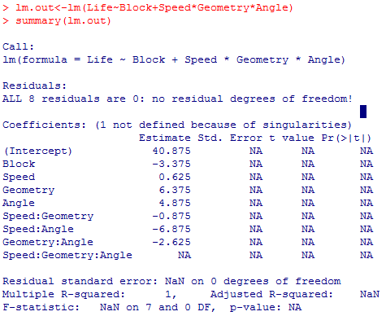(b)1)

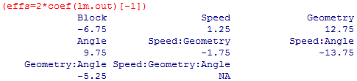

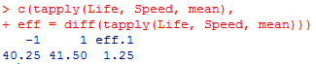2)

3)

4) Yes, the results are **consistent**.

5) The **effect of ABC** cannot be estimated. That’s because **it’s confounded**, with blocks.

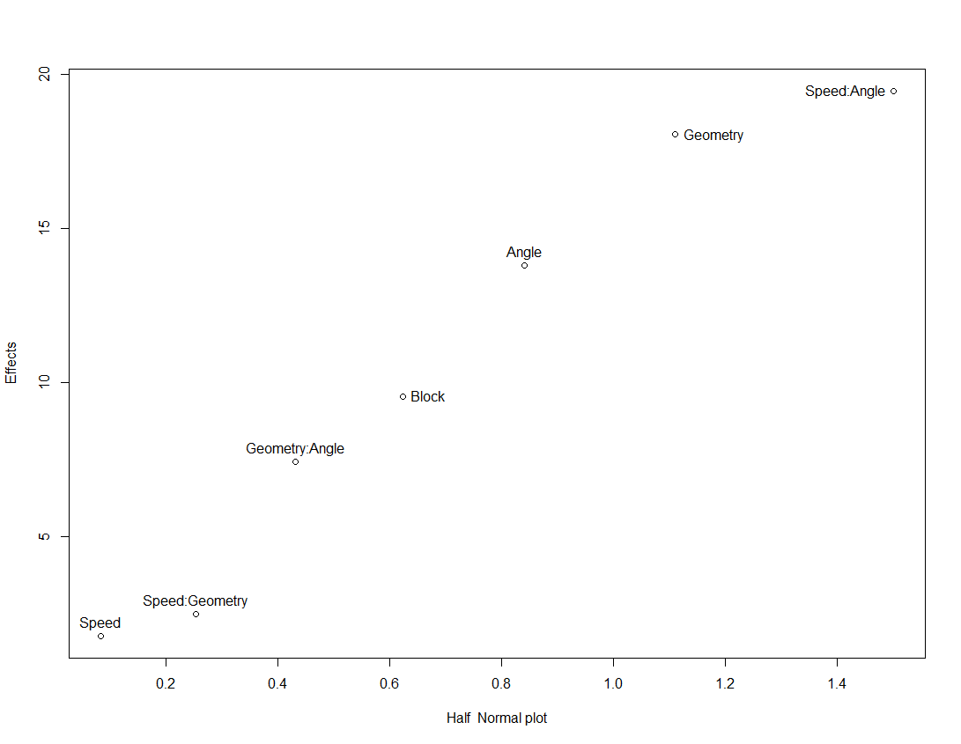(c) 1) According to the half-normal plot, the **Speed:Angle, Geometry, Angle, Block, Geometry: Angle** are large effect points.

2) According to the reduced model, the p-values for **Block, Geometry, Angle and Angle: Speed** are smaller than 0.05. Therefore we reject the H0 and conclude they are **significant**. For **Geometry: Angle**, the p-value is larger than 0.05 but smaller than 0.1, we say it’s **marginally significant**.

The outcome **is consistent with** the previous one.

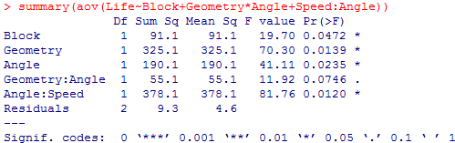

(d) 1) The table is:

|  |  |  |  |  |  |  |  |  |  |
| --- | --- | --- | --- | --- | --- | --- | --- | --- | --- |
| Treatment Combination | Factorial Effect | | | | | | | | |
| I | A | B | AB | C | AC | BC | ABC | Block |
| (1) | + | + | + | + | + | + | + | + | 1 |
| a | + | - | - | + | - | + | + | - | 1 |
| b | + | + | + | + | - | + | + | + | 2 |
| ab | + | - | - | + | - | + | + | - | 2 |
| c | + | + | - | - | + | + | - | - | 3 |
| ac | + | - | + | - | + | + | - | + | 3 |
| bc | + | + | + | - | + | - | - | - | 4 |
| abc | + | - | - | + | + | - | - | + | 4 |

2) The effect of **Speed and Geometry (AB), Speed and Angle (AC), Geometry and Angle (BC)** cannot be estimated because they are confounded by blocks.

**2. Problem 7.13:**

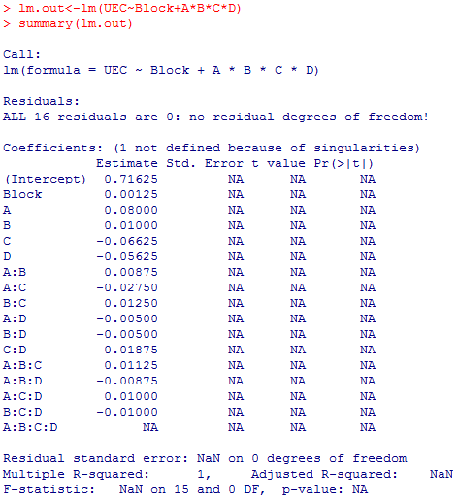(a) 1)

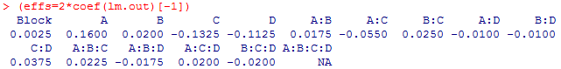

2) The **effect of ABCD** cannot be estimated because it’s confounded by blocks.

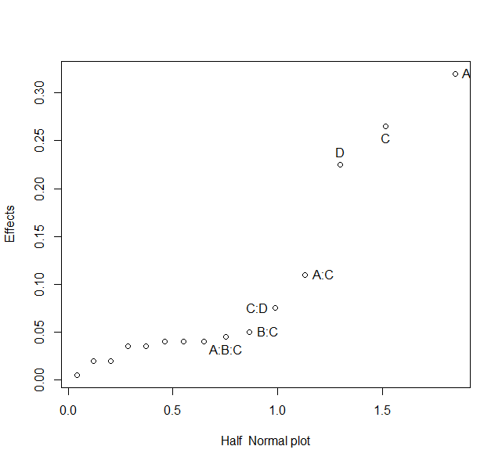3) According to the half-normal plot, **A, C, D** are important factors, **A:C, C:D** are marginally important factors.

(b) In that design, we cannot estimate the effect of **ABC, ABD, and CD**. That’s because ABC*ABD = A2B2CD = CD, they are confounded.

**3. Problem 7.24:**

(a) Partial Confounding:

|  |  |  |  |  |  |
| --- | --- | --- | --- | --- | --- |
| Replicate 1 | | Replicate 2 | | Replicate 3 | |
| ABC Confounded | | AB Confounded | | BC Confounded | |
| Block 1 | Block 2 | Block 1 | Block 2 | Block 1 | Block 2 |
| (1) | a | (1) | a | (1) | a |
| ab | b | c | b | b | c |
| ac | c | ab | ac | ac | ab |
| bc | abc | abc | bc | abc | bc |

(b) According to the ANOVA (next page), the **Geometry (B), Angle (C), Speed:Angle (A:C)** are significant.

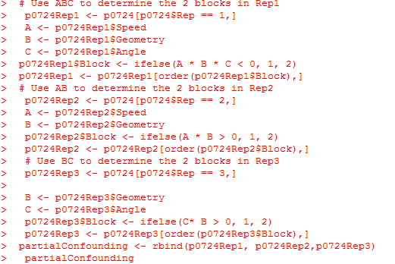

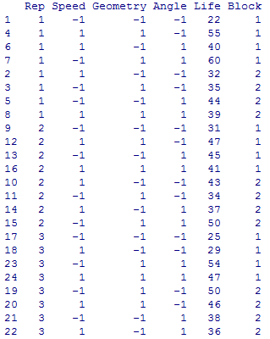

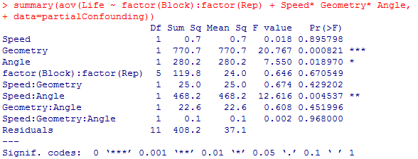

(c) 1) The **Geometry(B), Angle(C), Speed:Angle(A:C)** are significant. The outcome is **consistent** with the previous ANOVA test.

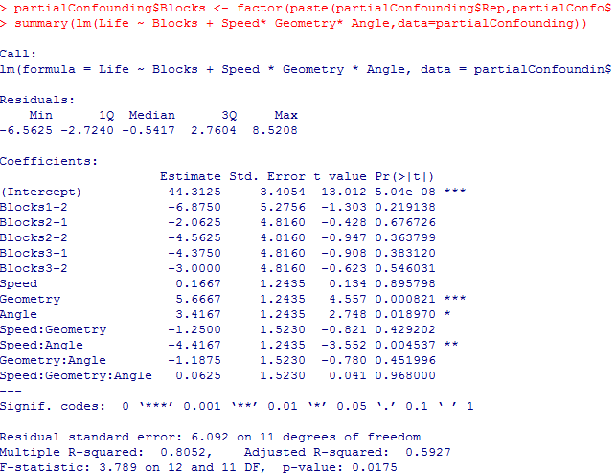2) Yes, **all effects can be estimated**.

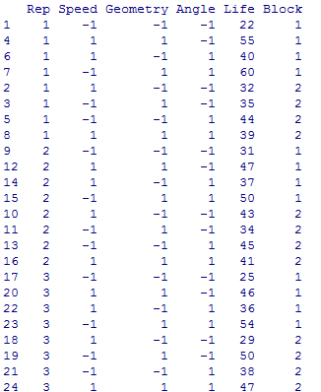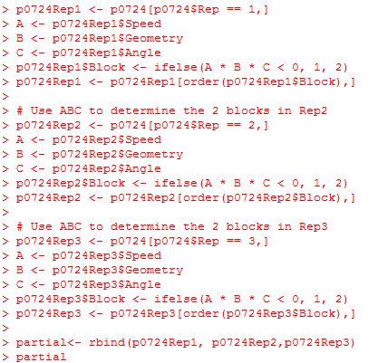(d) 1)

2) According to R, **Geometry (B), Angle(C), Speed: Angle(A:C)** are significant.

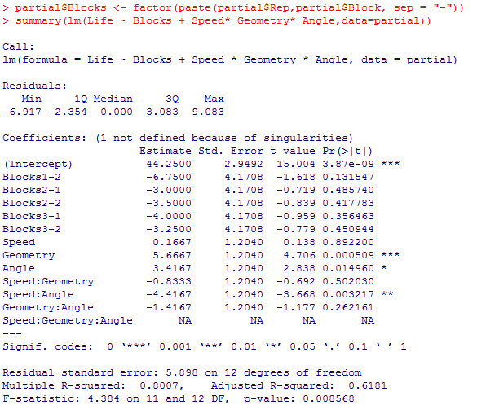

3) No, the **effect of ABC** cannot be estimated, it’s **confounded by two blocks** for each replicates.